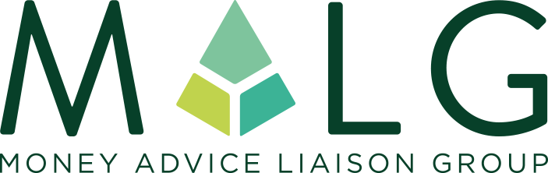
Working together to improve the lives of people in debt

National Business Membership Application Form
By applying to become a member of the Money Advice Liaison Group (MALG), your organisation is making a commitment to ‘work together to improve the lives of people in debt’.
National Business Membership is organisation-wide and opens up MALG member benefits (including access to National Members’ Meetings and applicable regional groups, and use of the MALG Member logo on communication materials including email signatures) to anyone who works for your organisation. The annual cost is £425 + VAT per annum – the main contact at your organisation will be invoiced on an annual basis and towards the end of your annual membership you will be reminded about your pending expiry and asked whether you would like to renew for another year.
Please complete the application form below and send the completed form to info@malg.org.uk. Your application will be reviewed and we will inform you if/when your application is accepted. On acceptance of your application, you will be issued with your annual invoice and the MALG Member logo guidelines. Your organisation’s logo and profile will then be added to the MALG website (using the details given below) and you/your relevant colleagues will be asked to give your permission to be added to our contacts database to receive regular updates and Members Meeting invitations.
NAME OF ORGANISATION INCLUDING ANY TRADING STYLES

COMPANY REGISTERED NUMBER

REGISTERED OFFICE ADDRESS

COMMUNICATION ADDRESS
(IF DIFFERENT)
ORGANISATION WEB ADDRESS (AS YOU WANT IT TO APPEAR ON THE MALG WEBSITE)
ORGANISATION DESCRIPTION (AS YOU WANT IT TO APPEAR ON THE MALG WEBSITE – 25 WORDS MAX)
VERSION OF YOUR ORGANISATION LOGO THAT YOU WOULD LIKE TO APPEAR ON THE MALG WEBSITE | VERSION ON WEBSITE LISTED ABOVE |  | VERSION ATTACHED
NAME OF MAIN CONTACT (FOR INVOICING AND OTHER MEMBERSHIP CORRESPONDENCE)

JOB TITLE
EMAIL ADDRESS

TELEPHONE NUMBER

IS YOUR ORGANISATION REGULATED? IF SO, PLEASE STATE THE REGULATOR

DO YOU HAVE PERMISSIONS TO HOLD CLIENT MONIES?

IS YOUR ORGANISATION A MEMBER OF ANY TRADE ASSOCIATION(S)? IF SO, PLEASE STATE THE TRADE ASSOCIATION(S)
HOW DID YOU HEAR ABOUT MALG?

MAIN REASON FOR JOINING (PREFERABLY IN TESTIMONIAL FORMAT THAT CAN BE USED ON THE MALG WEBSITE)
WHAT CREDENTIALS DO YOU BRING TO MALG?

We wish to apply for the following Regional Membership (please tick)

MALG MIDLANDS |  | MALG NORTH EAST & YORKSHIRE
MALG NORTH WEST |  | MALG NORTHERN IRELAND
MALG SCOTLAND |  | MALG SOUTH EAST
MALG SOUTH WEST

We hereby accept MALG’s purpose and support its aims

Signed.................................................................................................................

