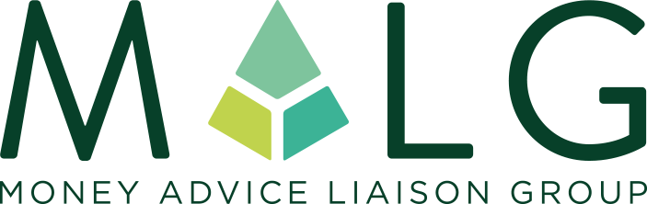
Working together to improve the lives of people in debt

National Business Membership Application Form
MALG is where creditors and advisers communicate openly, share views and best practice, increase understanding and professionalism, and engage effectively and constructively. MALG operates in a safe environment to come up with better ways to help people deal with their debt problems.
We wish to apply for the all inclusive National Business membership at a cost of £425 + VAT per annum. We attach our company logo for use by MALG and agree to use the MALG member logo on our appropriate channels.
NAME OF ORGANISATION INCLUDING ANY TRADING STYLES

COMPANY REGISTERED NUMBER

REGISTERED OFFICE ADDRESS

COMMUNICATION ADDRESS
(IF DIFFERENT)
ORGANISATION WEB ADDRESS (AS YOU WANT IT TO APPEAR ON THE MALG WEBSITE)
ORGANISATION DESCRIPTION (AS YOU WANT IT TO APPEAR ON THE MALG WEBSITE – 25 WORDS MAX)
NAME OF CHIEF EXECUTIVE OFFICER

NAME OF MAIN CONTACT

EMAIL ADDRESS

TELEPHONE NUMBER

IS YOUR ORGANISATION REGULATED? IF SO, PLEASE STATE THE REGULATOR
DO YOU HAVE PERMISSIONS TO HOLD CLIENT MONIES?
IS YOUR ORGANISATION A MEMBER OF ANY TRADE ASSOCIATION(S)? IF SO, PLEASE STATE THE TRADE ASSOCIATION(S)
HOW DID YOU HEAR ABOUT MALG?

MAIN REASON FOR JOINING (PREFERABLY IN TESTIMONIAL FORMAT THAT CAN BE USED ON THE MALG WEBSITE)
WHAT CREDENTIALS DO YOU BRING TO MALG?

We wish to apply for the following Regional Membership (please tick)

MALG MIDLANDS |  | MALG NORTH EAST & YORKSHIRE
MALG NORTH WEST |  | MALG NORTHERN IRELAND
MALG SCOTLAND |  | MALG SOUTH EAST

We hereby accept MALG’s purpose and support its aims

Signed..................................................................................................

Position................................................................................................

Payment

MALG Limited will follow up the application by sending through an invoice within 14 days

For further information please visit the MALG website www.malg.org.uk

