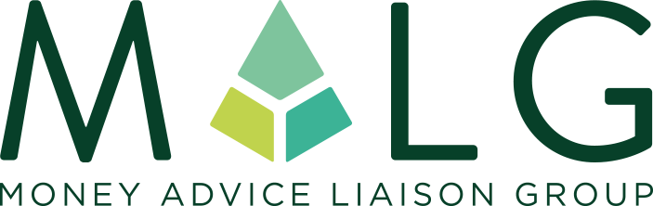
Working together to improve the lives of people in debt

Affiliate Membership Application Form
MALG is where creditors and advisers communicate openly, share views and best practice, increase understanding and professionalism, and engage effectively and constructively. MALG operates in a safe environment to come up with better ways to help people deal with their debt problems.
We wish to apply for the all inclusive Affiliate membership at a cost of £125 + VAT per annum. We attach our company logo for use by MALG and agree to use the MALG member logo on our appropriate channels.

NAME OF ORGANISATION

COMPANY REGISTERED NUMBER

REGISTERED OFFICE ADDRESS

COMMUNICATION ADDRESS
(IF DIFFERENT)
ORGANISATION WEB ADDRESS (AS YOU WANT IT TO APPEAR ON THE MALG WEBSITE)
ORGANISATION DESCRIPTION (AS YOU WANT IT TO APPEAR ON THE MALG WEBSITE – 25 WORDS MAX)
NAME OF CHIEF EXECUTIVE OFFICER

NAME OF MAIN CONTACT

EMAIL ADDRESS

TELEPHONE NUMBER

MAIN REASON FOR JOINING (PREFERABLY IN TESTIMONIAL FORMAT THAT CAN BE USED ON THE MALG WEBSITE)
WHAT CREDENTIALS DO YOU BRING TO MALG

We hereby accept MALG’s purpose and support its aims

Signed..................................................................................................

Position................................................................................................

Payment

MALG Limited will follow up the application by sending through an invoice within 14 days

Upon receipt of your payment, we will confirm your Membership Number and further details

For further information please visit the MALG website www.malg.org.uk

